Output:

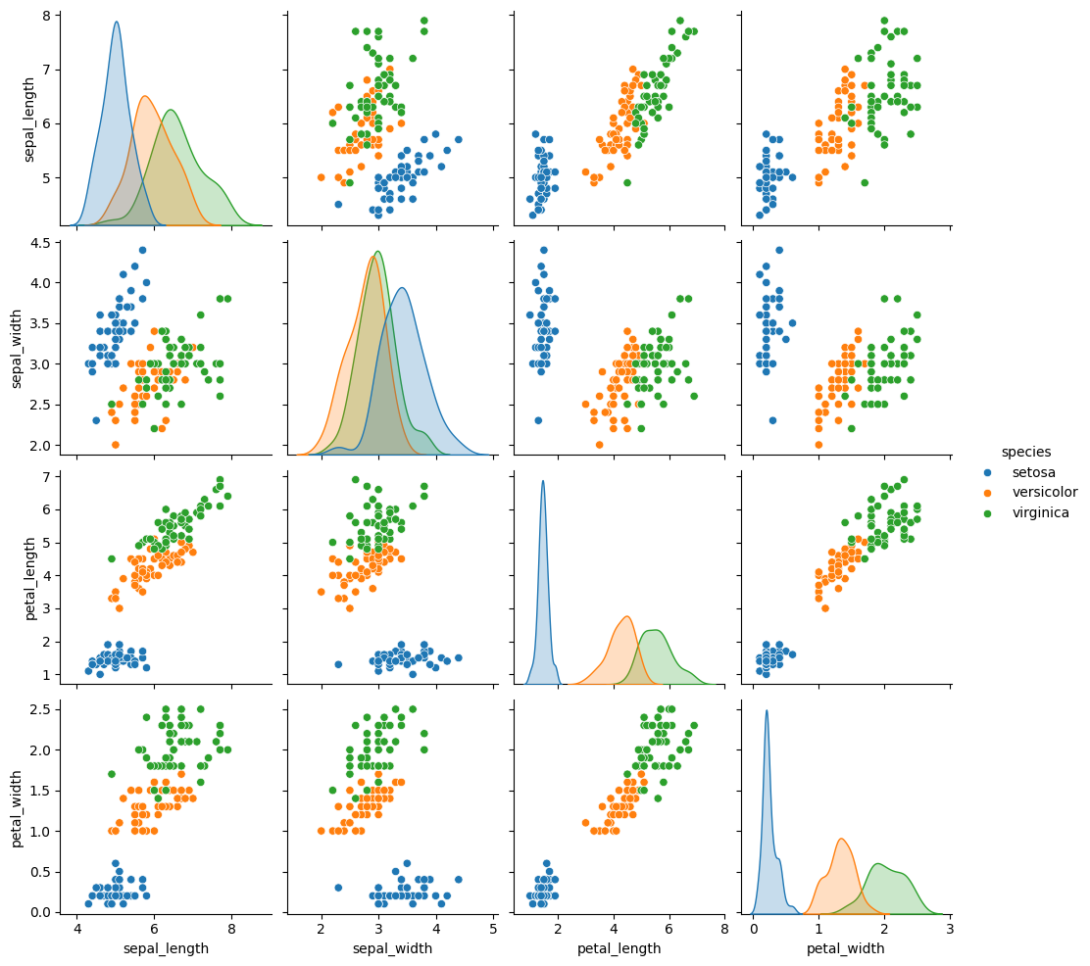

Confusion Matrix:

[[10 0 0]

[ 0 9 0]

[ 0 0 11]]

Classification Report:

precision recall f1-score support

setosa 1.00 1.00 1.00 10

versicolor 1.00 1.00 1.00 9

virginica 1.00 1.00 1.00 11

accuracy 1.00 30

macro avg 1.00 1.00 1.00 30

weighted avg 1.00 1.00 1.00 30

